**Image Style Transfer Using CNN**

***Under Asst. Prof. Jignesh Bhatt***

Shashank Gupta - 201751049

Anjali Priya - 201751007

Varnika Das Gupta - 201751060

**1. Introduction :-**

Transferring the style from one image onto another can be considered a problem of texture transfer. In texture transfer the goal is to synthesise a texture from a source image while constraining the texture synthesis in order to preserve the semantic content of a target image.

**2**. **Content and Style representations :-**

In order to get both the content and style representations of our image, we will look at some intermediate layers within our model. Intermediate layers represent feature maps that become increasingly higher ordered as you go deeper. In this case, we are using the network architecture VGG19, a pretrained image classification network. These intermediate layers are necessary to define the representation of content and style from our images. For an input image, we will try to match the corresponding style and content target representations at these intermediate layers.

*Content Loss*

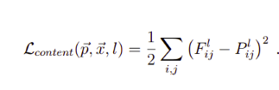

p and x be the original image and the image that is generated, and P and F their respective feature representation in layer l.

*Style loss*



Gijl  is the inner product between the vectorized feature maps i and j in layer ( G is a gram matrix).

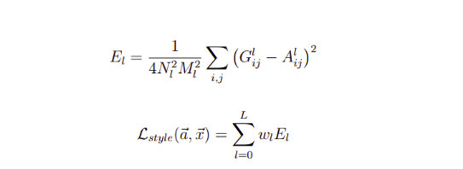

**3. Network Used :-**

We are using VGG 19 network, having convolution 19 layers. 16 convolution layers and in the end it has 3 FC(fully connected layers).

* Conv 3x3 (64)
* Conv 3x3 (64)
* MaxPool
* Conv 3x3 (128)
* Conv 3x3 (128)
* MaxPool
* Conv 3x3 (256)
* Conv 3x3 (256)
* Conv 3x3 (256)
* Conv 3x3 (256)
* MaxPool
* Conv 3x3 (512)
* Conv 3x3 (512)
* Conv 3x3 (512)
* Conv 3x3 (512)
* MaxPool
* Conv 3x3 (512)
* Conv 3x3 (512)
* Conv 3x3 (512)
* Conv 3x3 (512)
* MaxPool
* Fully Connected (4096)
* Fully Connected (4096)
* Fully Connected (1000)
* SoftMax

**4. Style transfer :-**

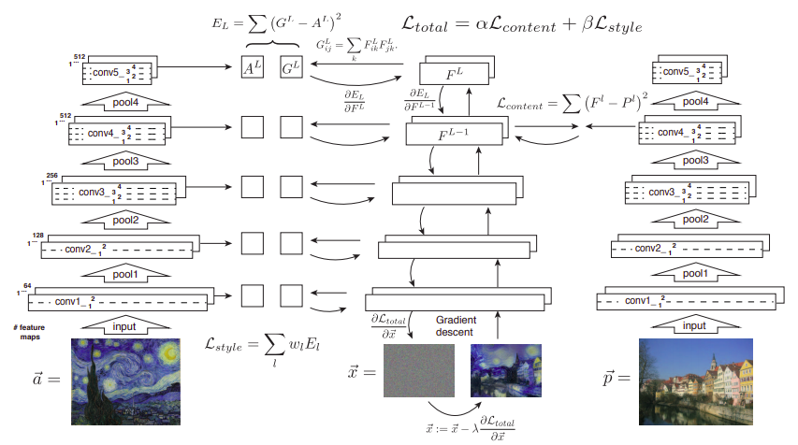

**5. Optimizer Used :-**

We are using Adam optimizer (adaptive moment estimation).Adam can be looked at as a combination of RMSprop and Stochastic Gradient Descent with momentum. It uses the squared gradients to scale the learning rate like RMSprop and it takes advantage of momentum by using moving average of the gradient instead of gradient itself like SGD with momentum.

**6. Results :-**

